DAY 13 REPORT
Task 1 – Comparison of X with Y and X with Z using Line Graph
Introduction
Matplotlib is a Python library used for creating graphs and data visualizations. It helps to compare datasets and represent numerical values graphically for better understanding and analysis.
Program
import matplotlib.pyplot as plt
x = [1,2,3,4,5]
y = [10,20,30,40,50]
z = [15,25,35,45,55]
plt.plot(x,y,label="X vs Y")
plt.plot(x,z,label="X vs Z")
plt.xlabel("X Values")
plt.ylabel("Y and Z Values")
plt.title("Comparison Graph")
plt.legend()
plt.show()

Functions Used
Function | Purpose
plt.plot() | Creates line graph
plt.xlabel() | Adds X-axis label
plt.ylabel() | Adds Y-axis label
plt.title() | Adds graph title
plt.legend() | Displays graph labels
plt.show() | Displays the graph

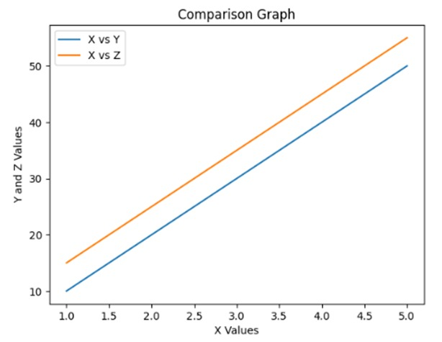
Output Description
- X vs Y is displayed as one line
- X vs Z is displayed as another line
Task 2 – Bubble Chart using Matplotlib
Program
import matplotlib.pyplot as plt
x = [1,2,3,4,5]
y = [10,20,30,40,50]
size = [100,200,300,400,500]
plt.scatter(x,y,s=size)
plt.xlabel("X Values")
plt.ylabel("Y Values")
plt.title("Bubble Chart")
plt.show()

Functions Used
Function | Purpose
plt.scatter() | Creates bubble/scatter graph
plt.xlabel() | Adds X-axis label
plt.ylabel() | Adds Y-axis label
plt.title() | Adds graph title
plt.show() | Displays graph

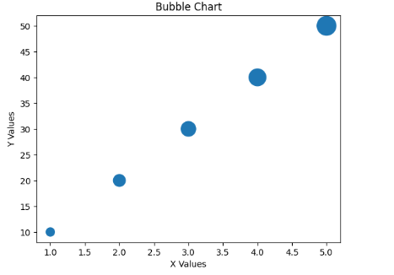
Output Description
- Bubble chart is displayed using scatter plot.
- Each point has different size based on the size list.
- It represents relationship between X and Y with magnitude.
Task 3 – Funnel Chart using Matplotlib
Program
import matplotlib.pyplot as plt
stages = ["Visit","Signup","Login","Purchase"]
y = [4,3,2,1]
plt.fill_betweenx([4.3,3.7], -50, 50, label="Visit")
plt.fill_betweenx([3.3,2.7], -40, 40, label="Signup")
plt.fill_betweenx([2.3,1.7], -30, 30, label="Login")
plt.fill_betweenx([1.3,0.7], -20, 20, label="Purchase")
plt.yticks(y, stages)
plt.xlabel("Users")
plt.ylabel("Stages")
plt.title("Funnel Chart")
plt.legend()
plt.show()

Functions Used
Function | Purpose
plt.fill_betweenx() | Creates filled horizontal regions
plt.yticks() | Sets stage labels
plt.xlabel() | Adds X-axis label
plt.ylabel() | Adds Y-axis label
plt.title() | Adds graph title
plt.legend() | Shows labels
plt.show() | Displays graph
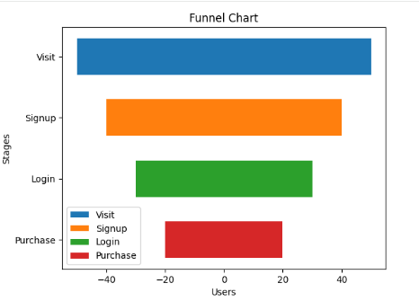
Output Description
- Funnel chart is created using decreasing widths.
- Shows user flow:
  - Visit → Signup → Login → Purchase
- Each step decreases representing drop-off.
Task 4 – Pyramid Chart using Matplotlib
Program
import matplotlib.pyplot as plt
levels = ["Top","Middle","Lower","Bottom"]
y = [4,3,2,1]
plt.fill_betweenx([4.5,3.5], -10, 10)
plt.fill_betweenx([3.5,2.5], -20, 20)
plt.fill_betweenx([2.5,1.5], -30, 30)
plt.fill_betweenx([1.5,0.5], -40, 40)
plt.yticks(y, levels)
plt.xlabel("Values")
plt.ylabel("Levels")
plt.title("Pyramid Chart")
plt.show()

Functions Used
Function | Purpose
plt.fill_betweenx() | Creates layered pyramid structure
plt.yticks() | Sets level names
plt.xlabel() | Adds X-axis label
plt.ylabel() | Adds Y-axis label
plt.title() | Adds graph title
plt.show() | Displays graph

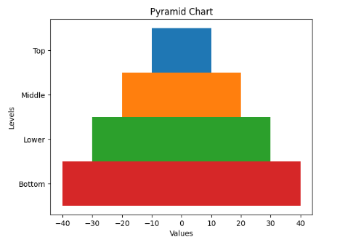
Output Description
- Pyramid structure is formed using layered blocks.
- Each level represents a hierarchy.
- Width increases from top to bottom.

Conclusion:
In this experiment, I learned how to create different types of graphs using Matplotlib. I understood how to compare datasets using line graphs, represent data using bubble charts, and visualize processes using funnel and pyramid charts. I also learned how different plotting functions like plot(), scatter(), and fill_betweenx() are used to create meaningful data visualizations.

